# Title Page

2307-BSE

Cross Platform Dev – Prototype

CS203.2

Will Tetzlaff (270155294)

# Document Outline

## Table of Contents

Title Page 1

Document Outline 2

Table of Contents 2

Table of Figures 2

Table of Tables 2

Report 4

Weekly Scrum Meeting/Minutes 4

Changes To Initial Plan 6

Collaboration 7

Roles/Responsibilities 7

Self-Reflection 9

## Table of Figures

Figure 1: Scrum Week 1 4

Figure 2: Scrum Week 2 4

Figure 3: Scrum Week 3 4

Figure 4: Scrum Week 4 4

Figure 5: Scrum Week 5 4

Figure 6: Scrum Week 6 4

Figure 7: Scrum Week 7 5

Figure 8: Scrum Week 8 5

Figure 9: GitHub Repo - Contributors 8

## Table of Tables

**No table of tables.**

Intentionally Blank

# Report

## Weekly Scrum Meeting/Minutes

Figure : Scrum Week 1

Figure : Scrum Week 2

Figure : Scrum Week 3

Figure : Scrum Week 4

Figure : Scrum Week 5

Figure : Scrum Week 6

Figure : Scrum Week 7

Figure : Scrum Week 8

## Changes To Initial Plan

We did have some changes due to various limitations which will be explained below:

* The prototype will not function on the WEB page like we had originally intended it to be for. This was due to the networking limitations of our backend code. We could have found a framework to allow packet transfer through the web however, unfortunately we ran out of time. The prototype is fully functional as an .exe file. This could theoretically be made to work on the web but would require more time in the future if we choose to expand upon the prototype we have completed.
* Some power ups were not implemented due to time constraints. We did not have enough time to implement all the powerups. This is because they would require significant coding time and testing time which we do not have. We have added a temporarily “this is not implemented yet” pop up into the game to prevent this as being a “bug”.
* There have been some changes to the game play itself, this was due to both time constraints and the fact the team agreed while developing/testing that the core mechanics needed to be changed to ensure we had a fun and playable game.

## Collaboration

### Roles/Responsibilities

Each team member was put in roles that they felt they were strong in. This made sure everyone was working on something they were confident in doing which made the work go a lot quicker and smoother.

Alex L:

* **Primary Backend Developer** – Is responsible for the development and maintainability of the backend related code. This may include some interfaces which allow front end code to work with back-end code.
* **Project Manager** – Is responsible for the overall project and any issues that may arise during said project.
* **Product Analyst** – Is responsible for looking into products to find strengths and weaknesses to help the development of products by learning from these strengths and weaknesses.

Alex C:

* **Scrum Master** – Is responsible for keeping everyone on task and on time. They can make meetings with the team to bring everyone together and get everyone on track again.
* **Product Analyst** – Is responsible for looking into products to find strengths and weaknesses to help the development of products by learning from these strengths and weaknesses.
* **Devil’s Advocate** – Is responsible for making decisions that the group can’t decide on together and critiquing all work within the project to make sure it is up to standard.

Will T:

* **Concept Programmer** – Is responsible for creating backend related code concepts which will be able to prove theoretical code related concepts.
* **Main Designer UX** – Is responsible for the development of the LoFi and HiFi prototypes and designs for the project.
* **Concept Testing** – Is responsible for user testing of the prototypes and concepts required within the project.

Liam K:

* **Hype Man** – Is responsible for keeping the team hyped up and on task. Keeping the motivation up during any tough times.
* **Target Audience Analyst** – Is responsible for knowing and researching the target audience for the project.
* **Concept Manager** – Is responsible for the overall concept of the project and making sure the prototype is what was expected as the overall concept.

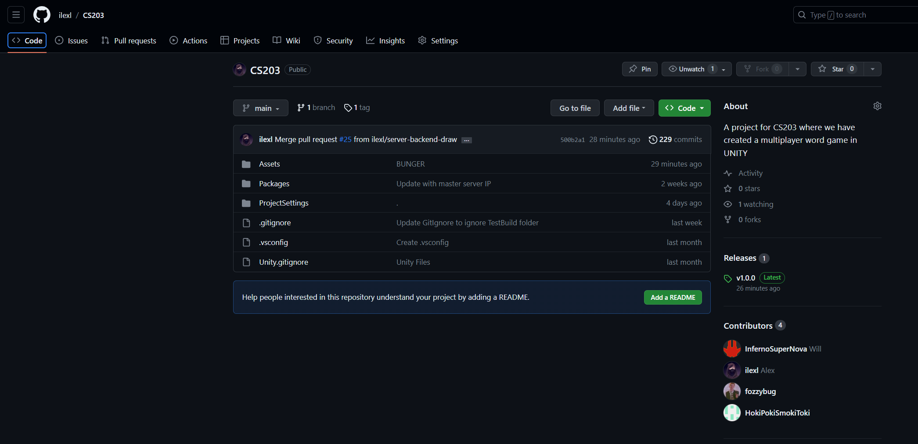

Figure : GitHub Repo - Contributors

All four of us have contributed to the development of the prototype in some way or another – specifics can be found on <https://github.com/ilexl/CS203> as there are too many, however we all worked collaboratively which resulted in us being able to produce a functional prototype by the end date.

## Self-Reflection

**Reflection on learning in terms of technology:**

Answer HERE

**Reflection on the project overall:**

Answer HERE (Make sure to say how the prototype and MVP were completed on schedule)

**Reflection on what you would do differently next time:**

Answer HERE